1. Install docker

Minimum requirement docker version 17.10, download docker dengan menjalankan perintah :

$ curl -O https://download.docker.com/linux/centos/7/x86_64/stable/Packages/[docker-ce-17.12.1.ce-1.el7.centos.x86_64.rpm](https://download.docker.com/linux/centos/7/x86_64/stable/Packages/docker-ce-17.12.1.ce-1.el7.centos.x86_64.rpm)

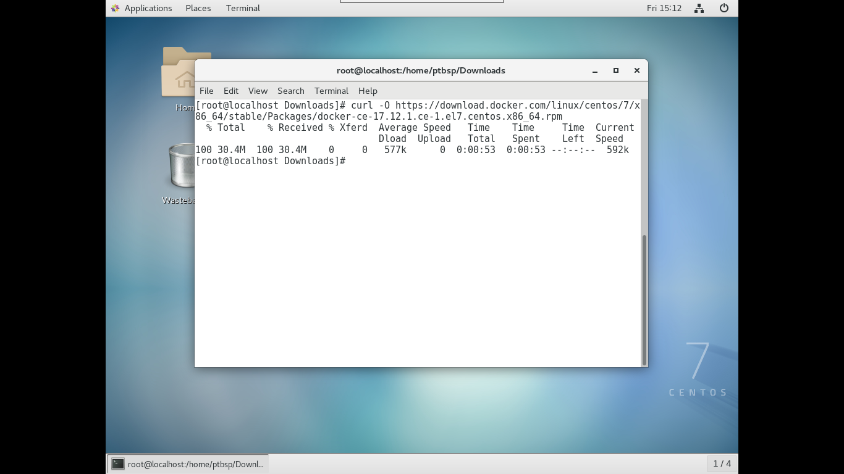

install docker dengan menjalankan perintah :

$ chmod +x docker-ce-17.12.1.ce-1.el7.centos.x86_64.rpm

$ yum install docker-ce-17.12.1.ce-1.el7.centos.x86_64.rpm

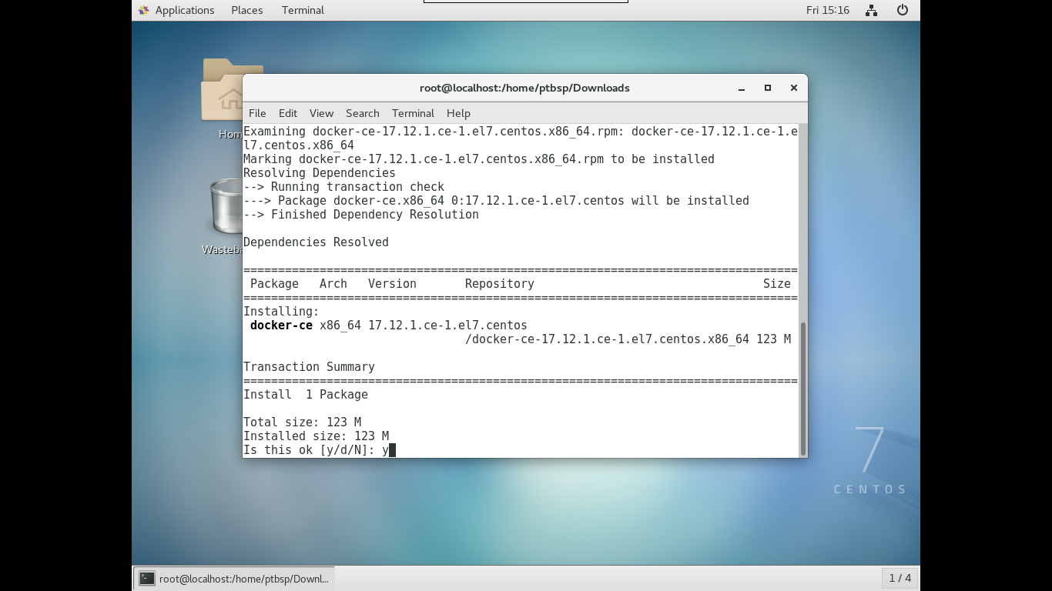

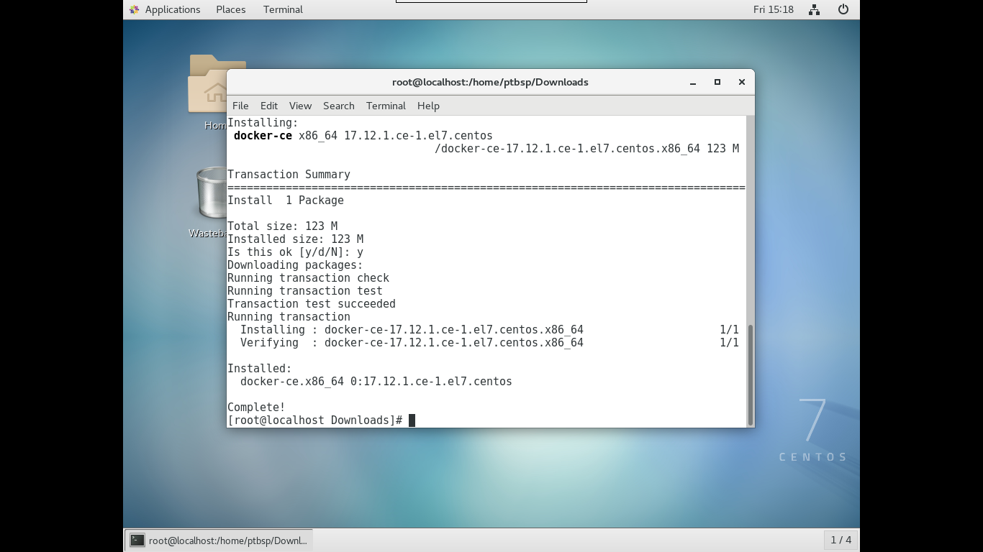

1. Enable dan Start docker

$ systemctl enable docker && systemctl start docker

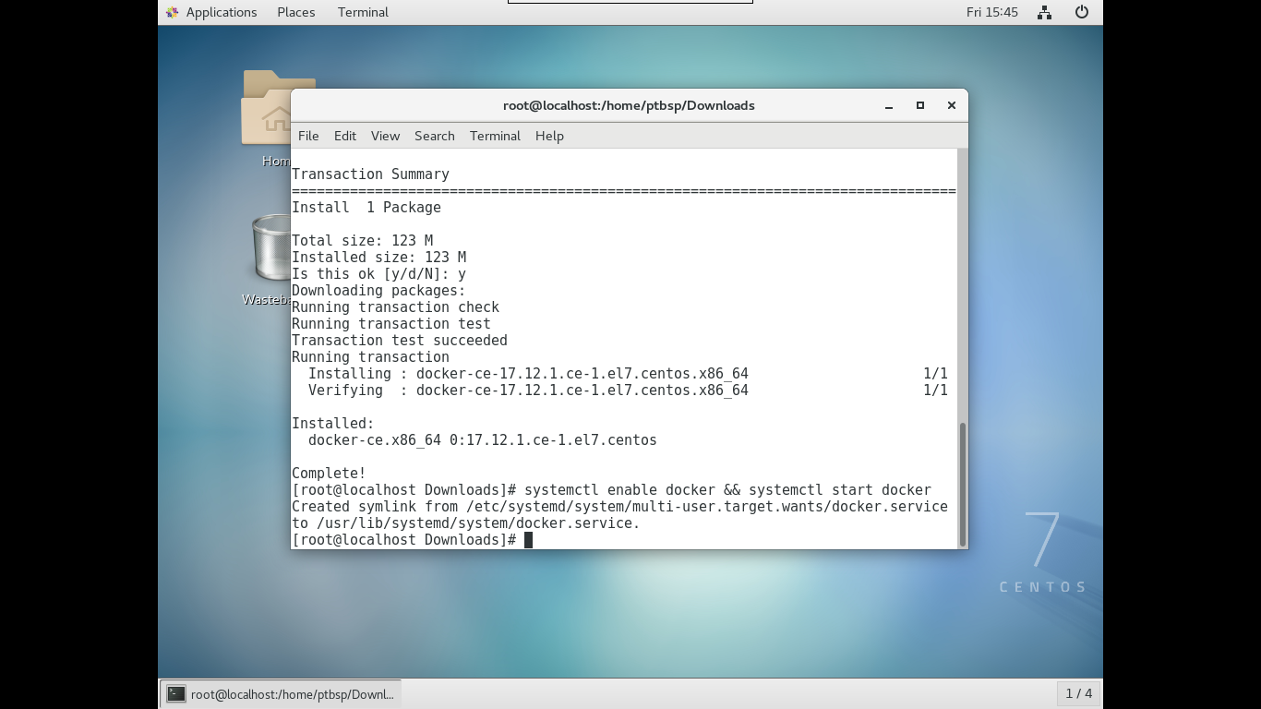

1. Install Fnproject

$ curl -LSs https://raw.githubusercontent.com/fnproject/cli/master/install | sh

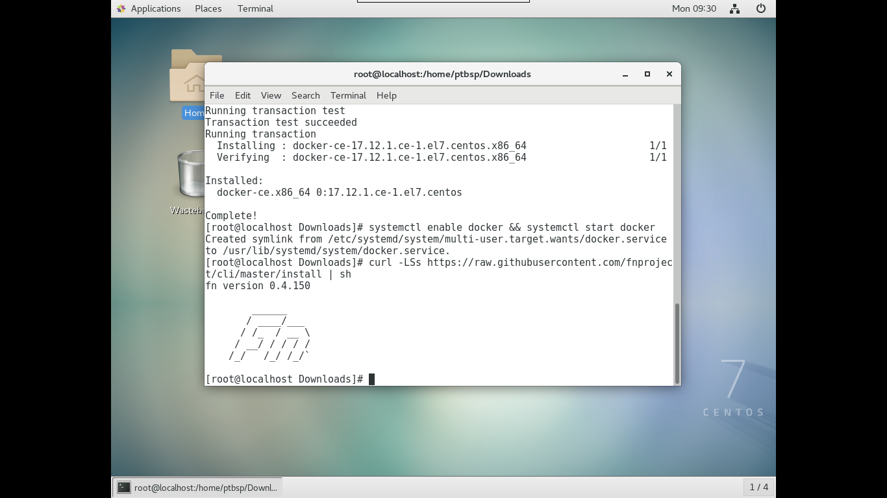

1. Run fnproject

$ fn start

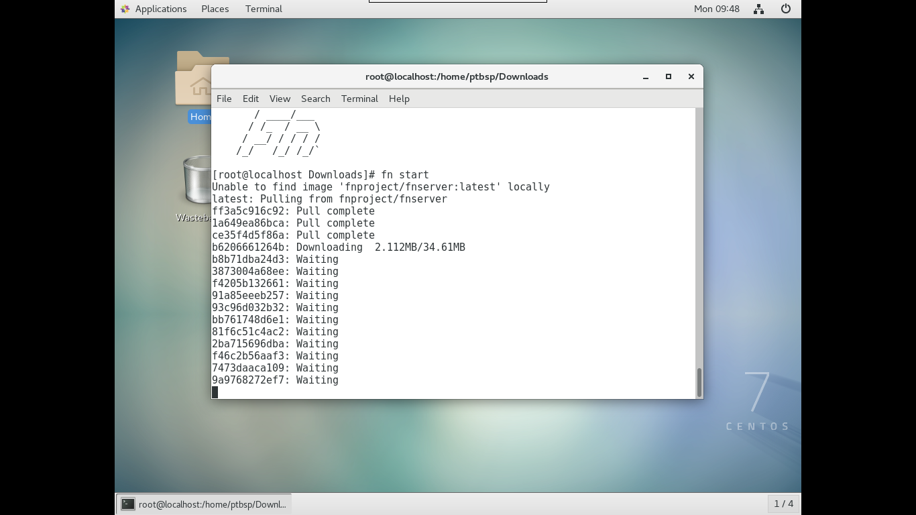

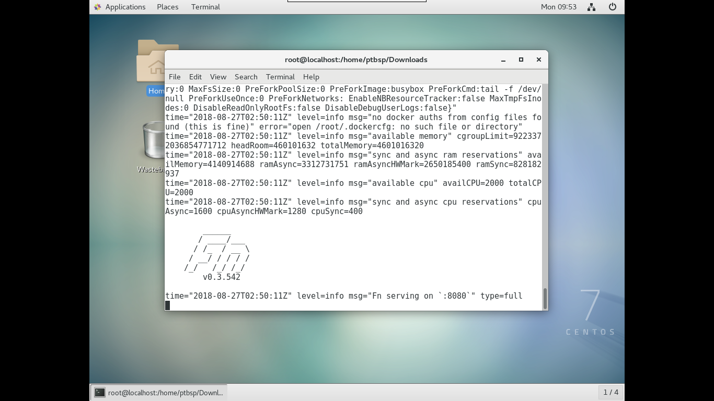

Akses portal Fnproject dengan alamat http://localhost:8080 atau http://127.0.0.1:8080

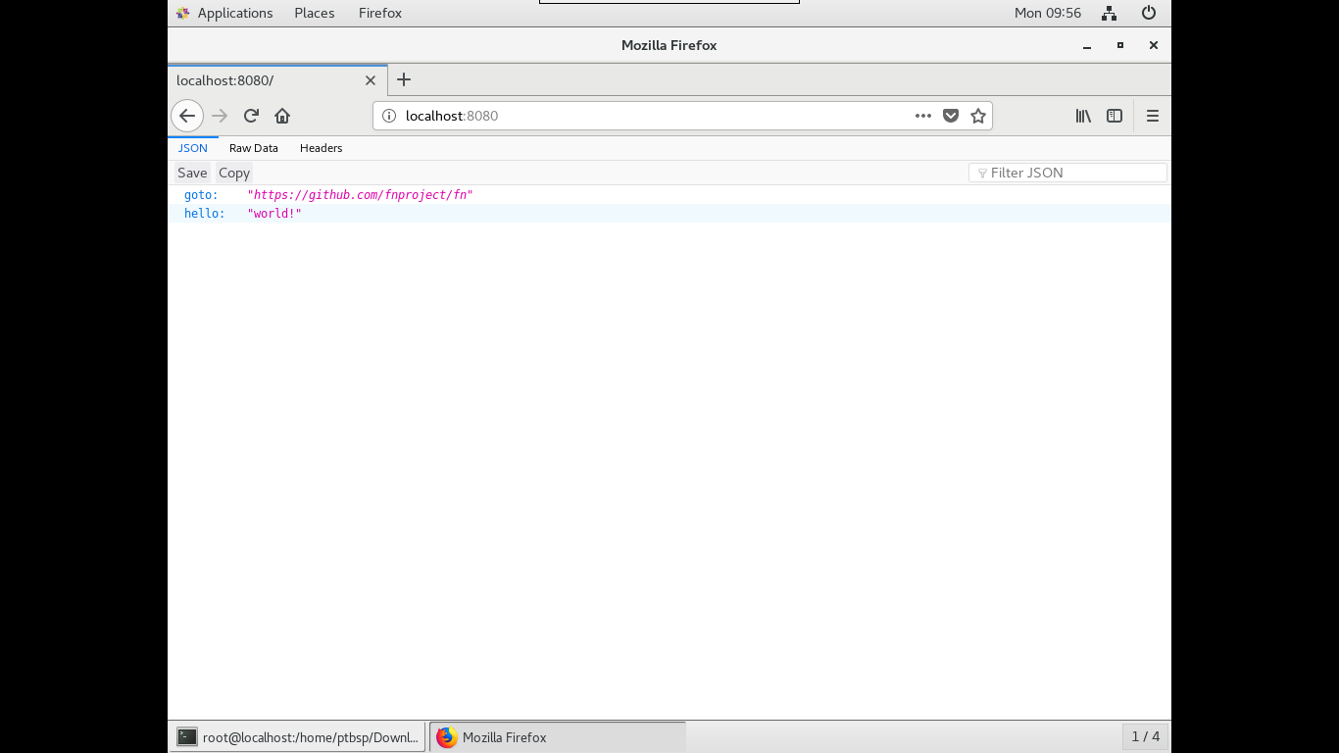

1. Initialize Fnproject

$ fn init --runtime go hello

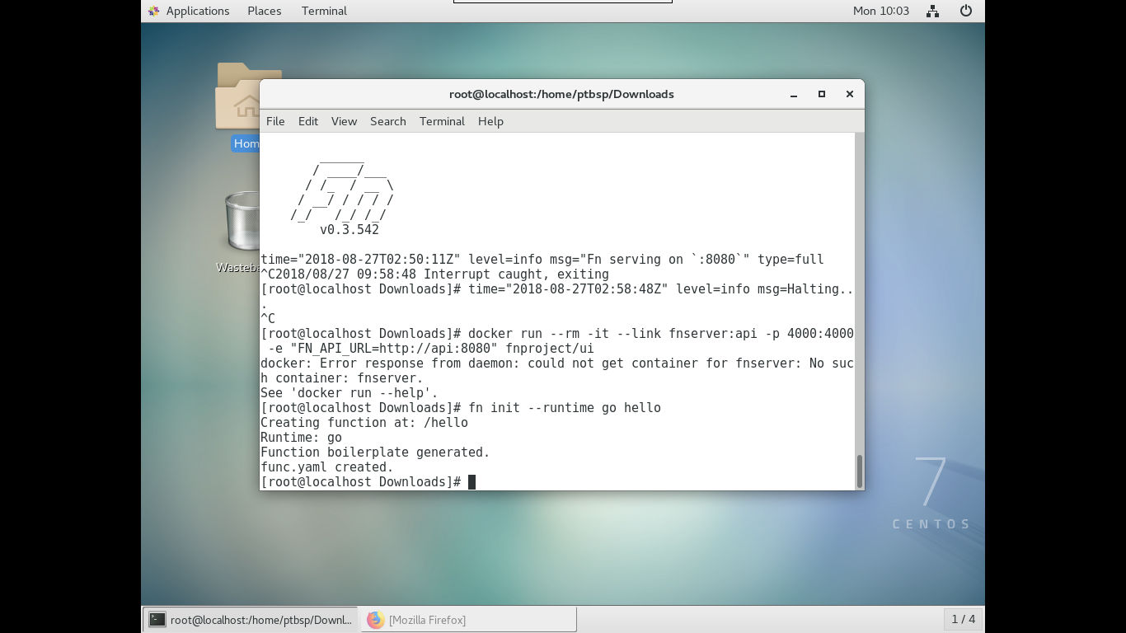

$ cd hello

$ fn run

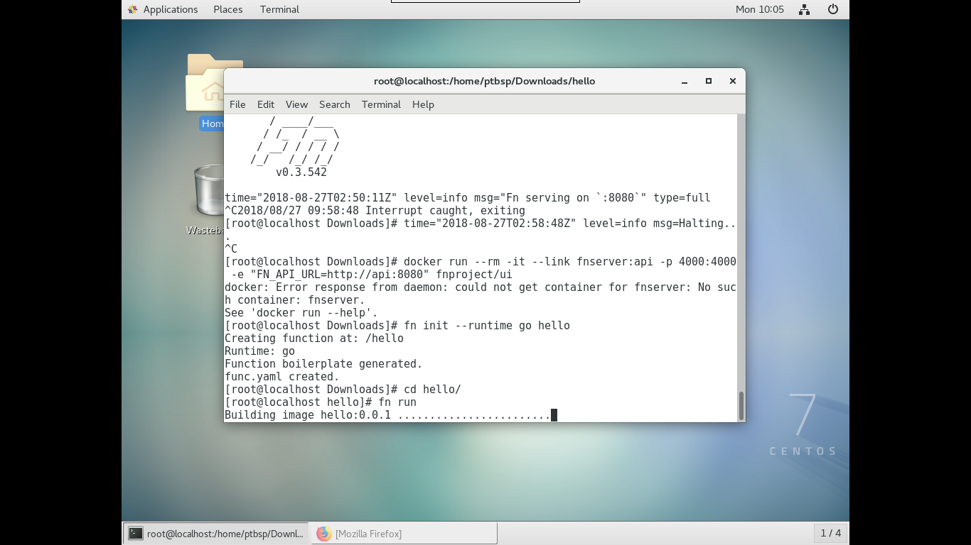

$ fn deploy --app myapp --local (pastikan fnproject sedang running)

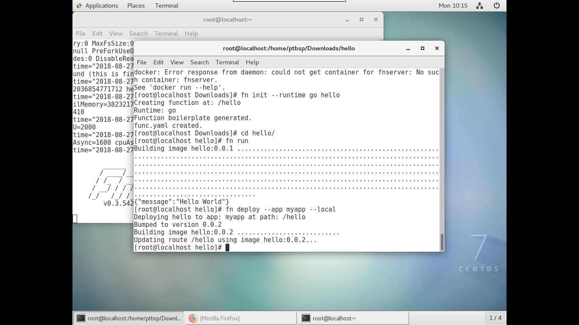

1. Install User Interface Fnproject (pastikan fnproject sedang running)

$ docker run --rm -it --link fnserver:api -p 4000:4000 -e "FN_API_URL=http://api:8080" fnproject/ui

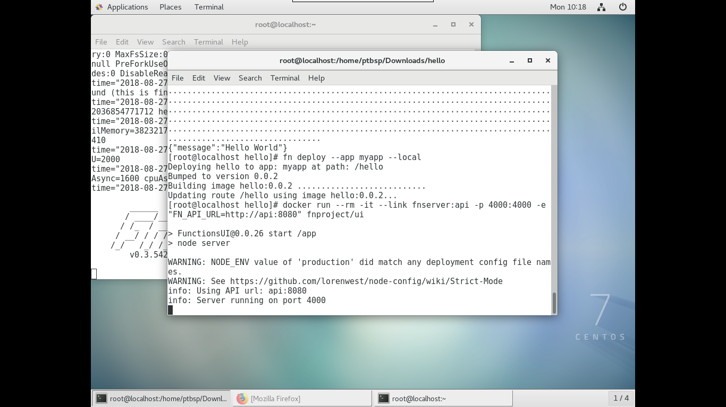

Akses portal Fnproject dengan alamat http://localhost:4000 atau http://127.0.0.1:4000

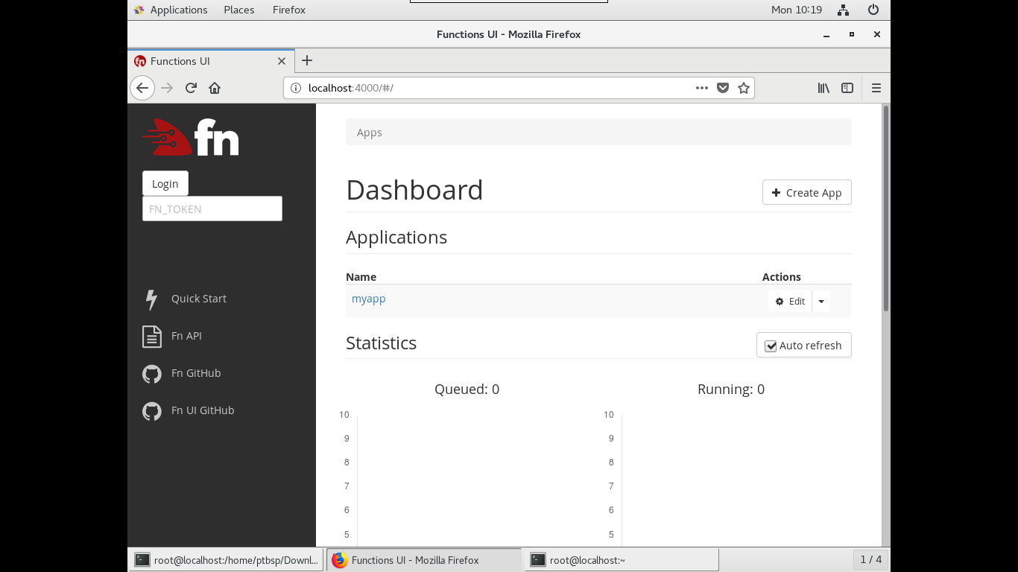

1. Create java hello world

$ mkdir fn-java-function

$ cd fn-java-function

$ fn init --runtime java hello-java

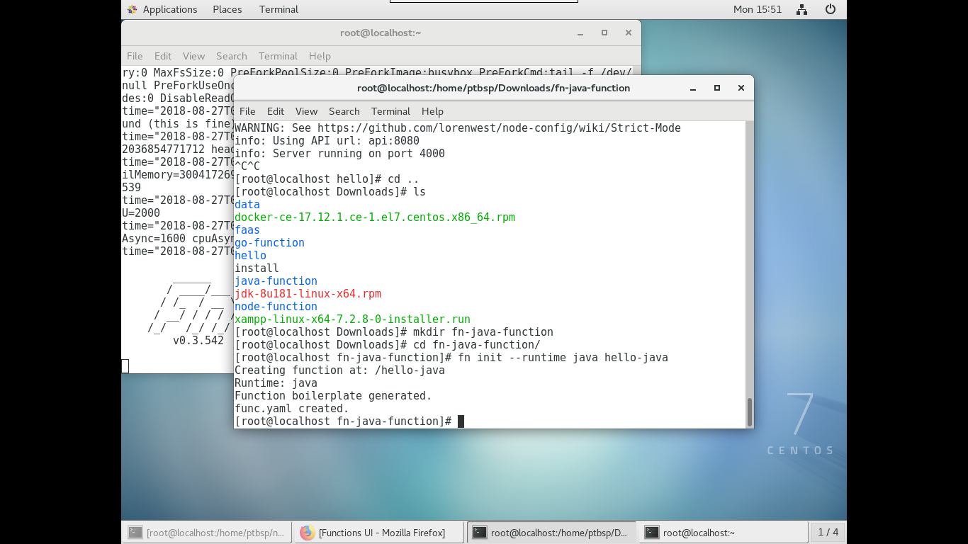

$ cd hello-java

$ fn run

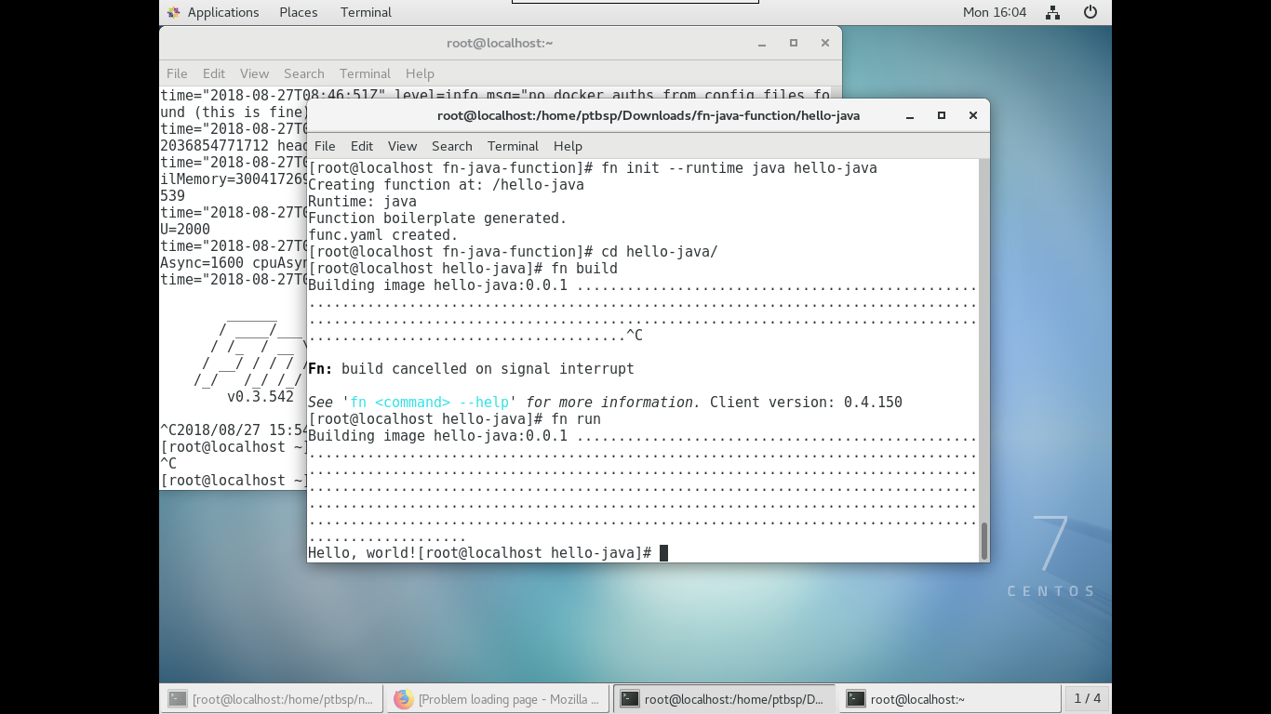

$ fn deploy --app hellojava --local

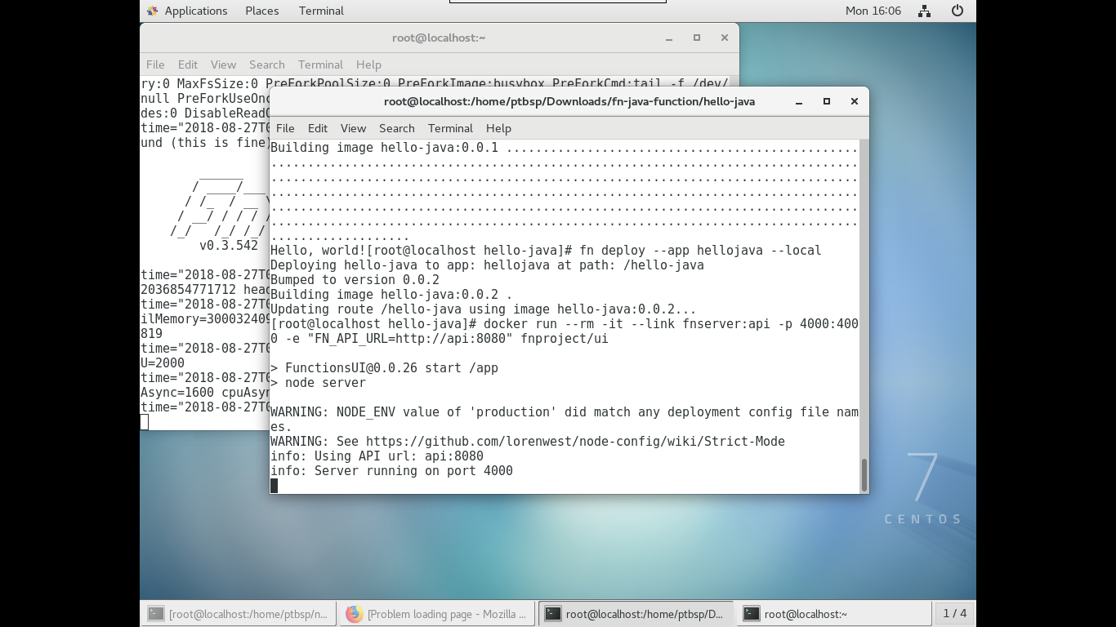

Run hello-java di Fnproject User Interface

